

AHU CONTROLLER TEST DATA SHEET

P/N: N/A Date: 20/03/2018 Time: 10:48

S/N: N_A Tested by: iuhjg

Hardware Rev: BLDC_60A_V6 Approved by: iuhjg

Software Rev: N/A

Tester Software Version: 1.2d

Equipments Used

Equipments Model No Serial No

Power Supply

Digital Multimeter

CAN Interface

Resistance Decade Box

PC

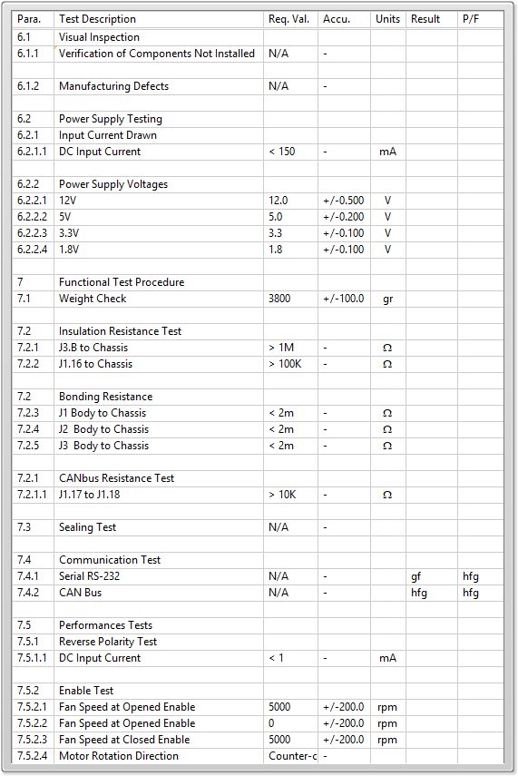

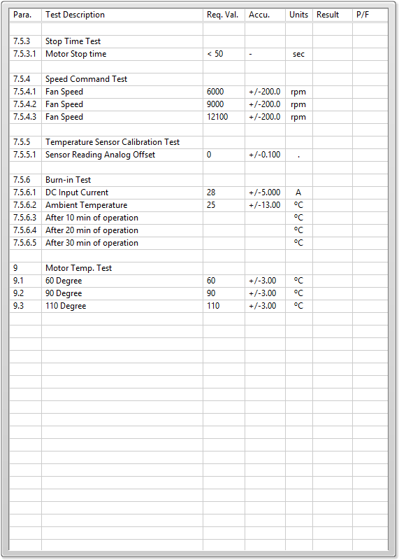

General result:

Test-Operator:____ iuhjg_________ Q.A.:__________________________